Department of Commerce
Department Profile –
Photo | 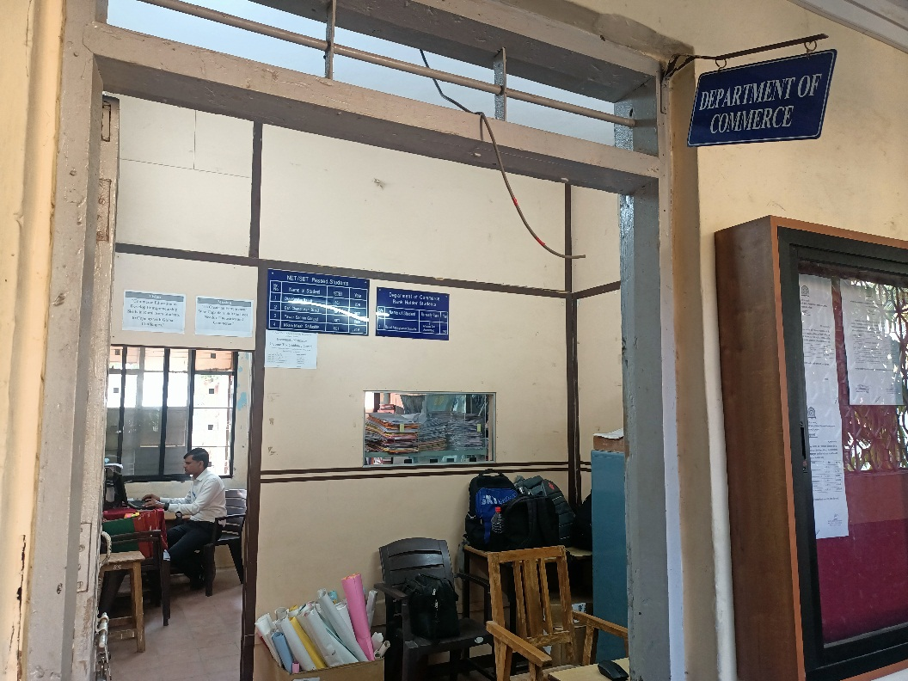
Establishment Year | B.com. - 1967  M.com. - 1979
Intake | B.com. – 240  Granted – 120  Non- Granted - 120  M.com. - 60
Duration of Course (Years) | B.com. -3 Years  Specialisation –  - Cost & Works Accounting  - Business Administration  - Marketing Management  - Banking & Finance  M.com. – 2 Years  Specialisation –  - Cost & Works Accounting  - Business Administration
Location | Main Building, Ground Floor
Contact | -
Vision | To Develop Entrepreneurship Skills in Rural Area Students to Cope up with Global Challenges.
Mission | To Create an Entrepreneur who capable to suit the local needs of Industries and Commerce.

Commerce HOD Desk

HOD Photo | 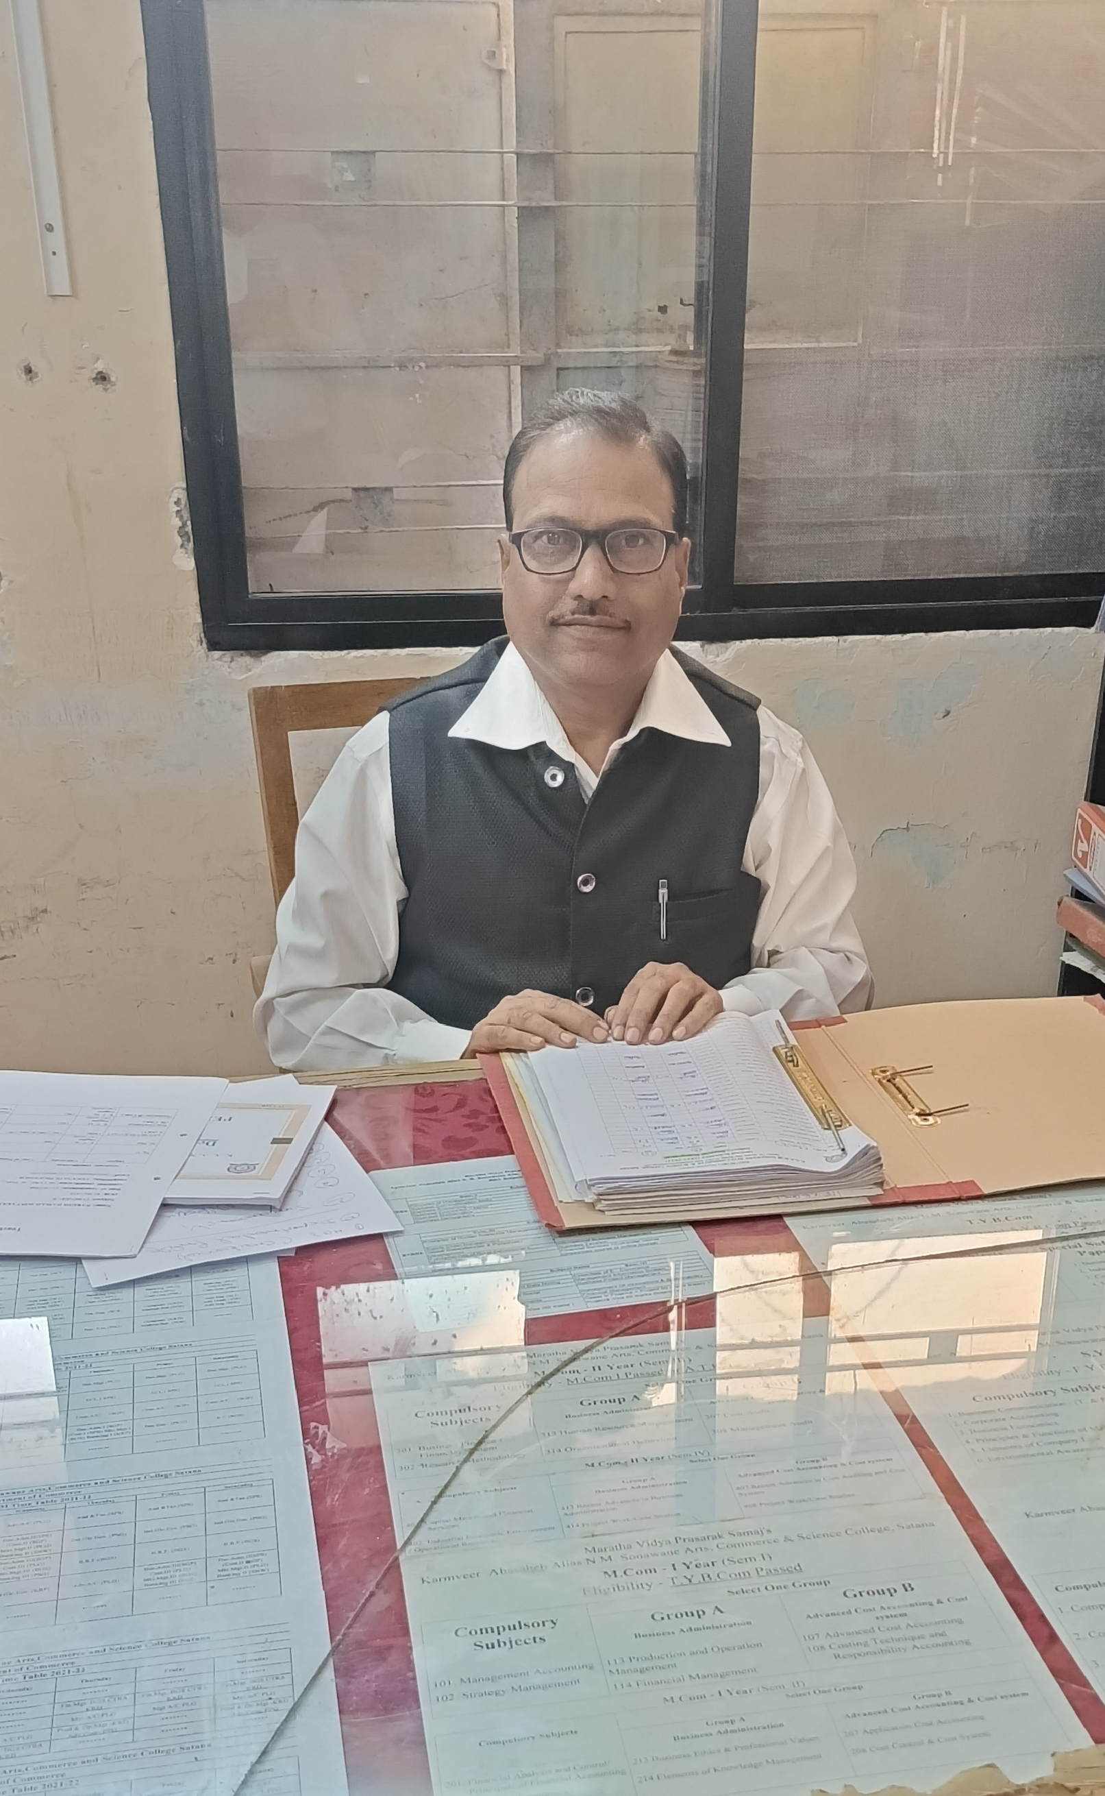
HOD Name (Full Name) | Mr. Naresh Damaji Sontakke  (Associate Professor)
Education | M.Com. , M. Phil. , NET
Email-Id | Nareshsontakke11@gmail.com
About Department (Description from HOD point of view) | Department of Commerce of Karmveer Abasaheb Alias N.M. Sonawane Arts, Commerce and Science College, Satana has been established with B.Com in 1967 providing four special subjects. And M.Com. PG Course with two special subjects in 1979 to Develop Entrepreneurship Skills in Rural Area Students to Cope up with Global Challenges and to Create an Entrepreneur who capable to suit the local needs of Industries and Commerce.

Department of Commerce Staff List
(Add this staff members in Commerce faculty )
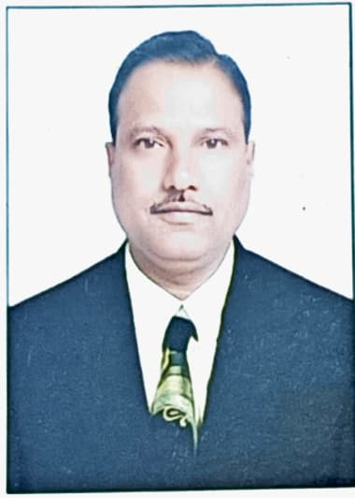 | Name: Mr.N. D. Sontakke  Designation: Associate Professor  Qualification: M.Com. , M. Phil. , NET  Experience: 24 Yrs.
 | Name: Smt. M.P. Aher  Designation: Assistant Professor  Qualification: M.Com. B.Ed.  Research:  Experience: 1Yr.
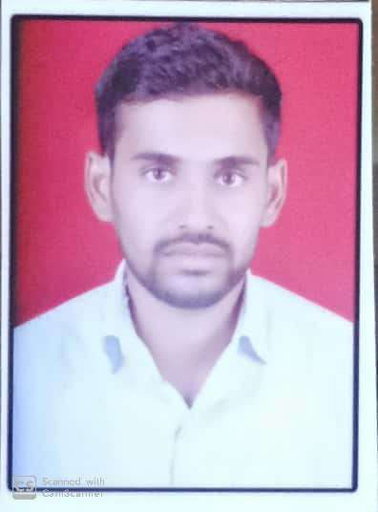 | Name: Mr. N. S. Nikam  Designation: Assistant Professor  Qualification: M.Com. SET.  Experience: 6 Yrs.

Note- Delete the Profile of :
- P. L. Gaikwad (HOD)
- S. P. Suryawanshi
- Pradip Nikam

Faculty Achievement
Academic Year 2021-22
Sr. No. | Name of the Staff | Achievement Certificates | Category (Paper / Workshop / FDP / Seminar / STTP) | National / International/ State/ Institute Level | Role | Year
1 | Mr. N. D. Sontakke | Global Teacher Award | - | International | - | 2021
2 | Dr. B. G. Sable | Ph. D. | - | - | - | 2022

Student Achievements

Name of the Student | Exam. | Year
Dani Kudan Bapuji | SET | 2011
Dani Chandrakant Bapuji | SET | 2012
Pawar Sachin Ganpat | SET | 2015
Nikam Nilesh Sadashiv | SET | 2015
Chandratre Rishikesh Sunil | L L.B. | 2020-21
Godhede Swapna Kailas | SET | 2021-22
Suryawanshi Kishor Ramsing | SET | 2021-2022
Thoke Manish Harsing | SET | 2021-2022
Ahir Monika Pramod | B. Ed | 2021-22

Prominent Alumni of Department of Commerce
Sr. No. | Name | Year | Organization | Designation
 | Dani Kudan Bapuji | 2005-2006 | - | Assistant Professor
 | Dani Chandrakant Bapuji | 2005-2006 | KRA College Deola | Assistant Professor
 | Pawar Sachin Ganpat | 2010-2011 | MVP Nashik | Assistant Professor
 | Nikam Nilesh Sadashiv | 2011-2012 | MVP Nashik | Assistant Professor
1. | Yogesh Borse | 2019-2020 | WIPRO | Project Enginer
2. | Shubham Raundal | 2020-2021 | Reliance General Insurance | Sales Manager
3. | Mahesh Ahire | 2018-2019 | TCS | System Enginer
4. | Chandratre Rushikesh Sunil | 2020-2021 | BCI (MS&Goa) | Advocate
5. | Sonawane Kanchan Ashok | 2021-2022 | HDFC Financial Services | Sales Executive
6. | Jadhav Sanjana Sanjay | 2020-2021 | Shir-Ram City Finance Satana | Executive Credit Admin
7. | Vaibhav Pawar | 2022-2023 | Won Grampanchayat Election | Sarpanch
8. | Nikita Shewale | 2021-2022 | Writer Business Services Pvt. Ltd. | Associate Grade M-07
9. | Rutuja Patil | 2021-2022 | Makarand M.Joshi & Co. | Sub-Team Leader
10. | Yogesh Wagh | 2020-2021 | Shir-Ram City Finance Satana | Jr. Executive

Department Activities –
Name of Activity | Photo
Lecture on Tax Planning | 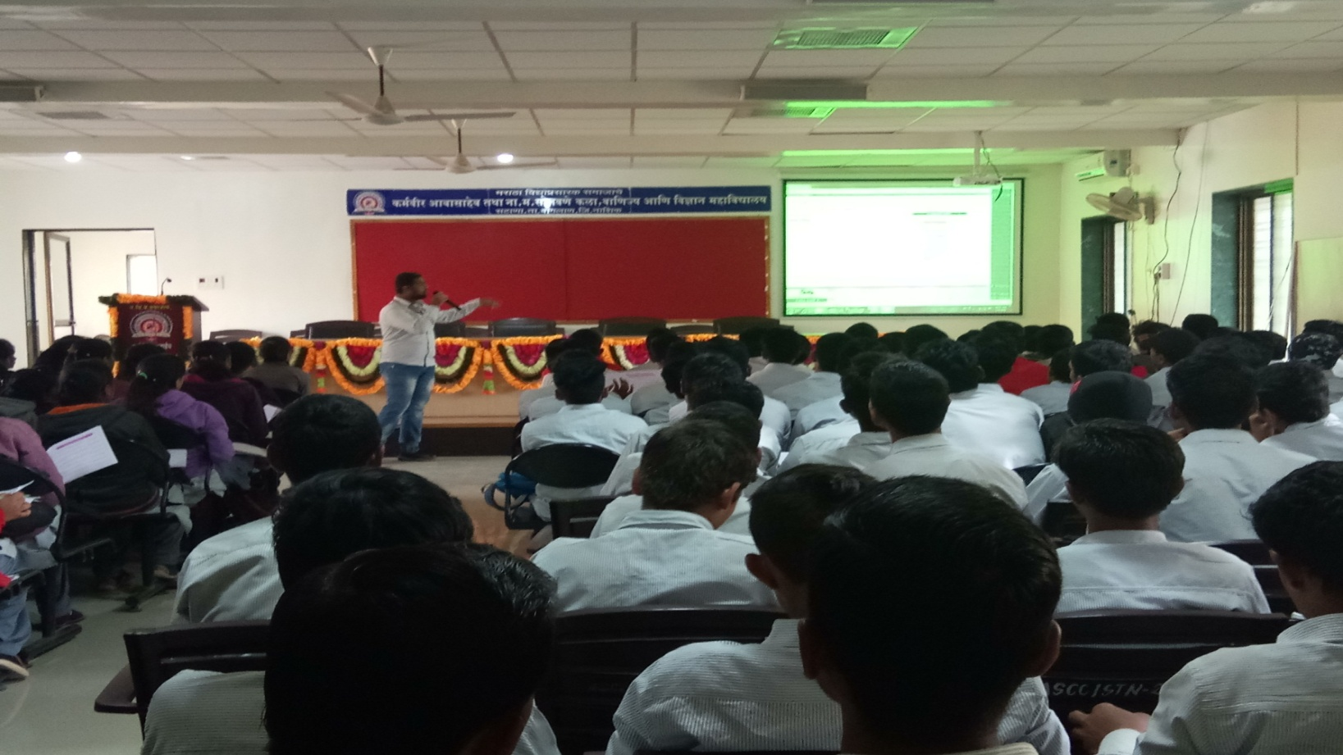
Field Visit | 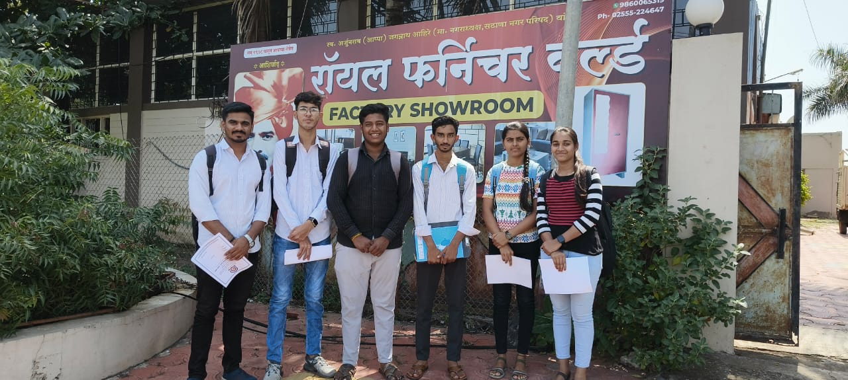
 | 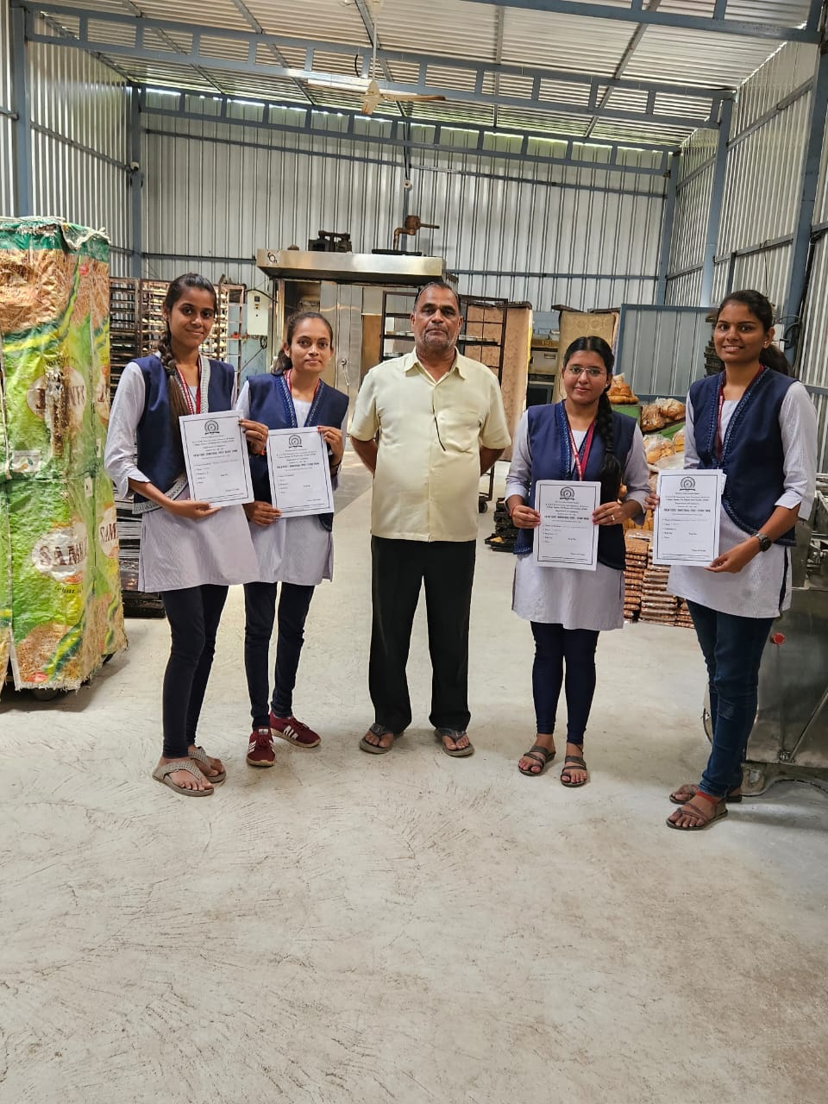
Swachha Bharat Mission | 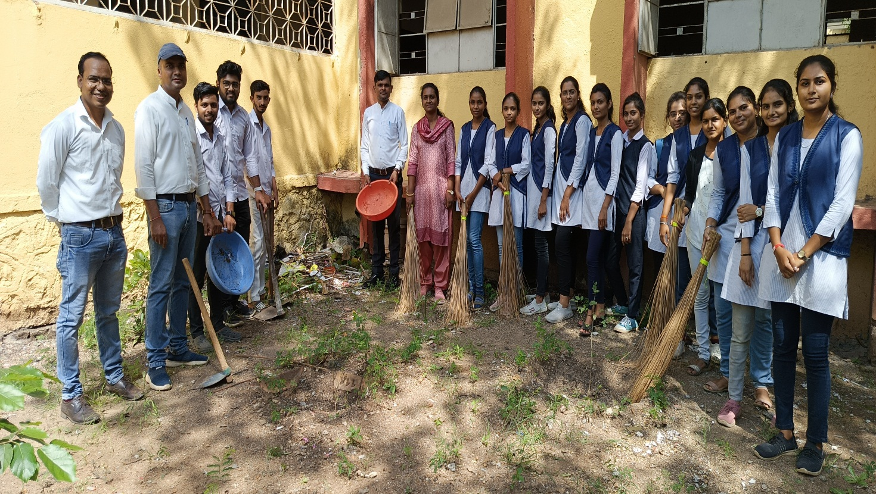
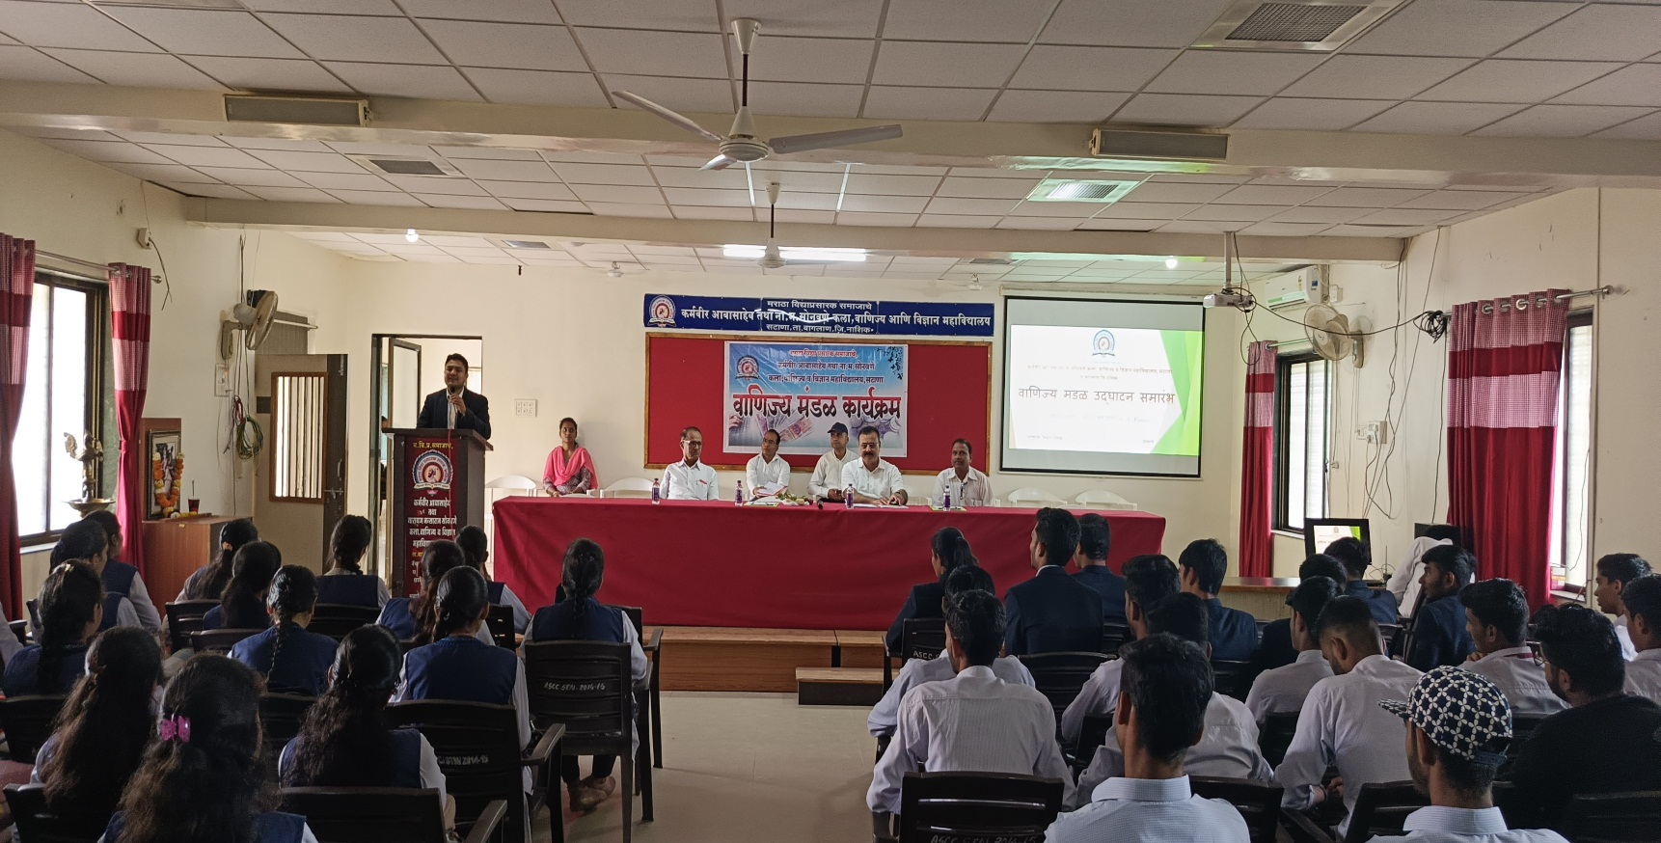
वाणिज्य मंडळ उद्घाटन कार्यक्रमप्रसंगी मार्गदर्शन करतांना – सनदी लेखापाल राजेंद्र डांगी (पुणे)

